**Project Design Phase-II**

**Technology Stack (Architecture & Stack)**

|  |  |
| --- | --- |
|  |  |
| Team ID | NM2025TMID07828 |
| Project Name | Optimizing User, Group, and Role  Management with Access Control and  Workflows |
| Maximum Marks | 4 Marks |

**Technical Architecture:**

The Deliverable shall include the architectural diagram as below and the information as per the table1 & table 2

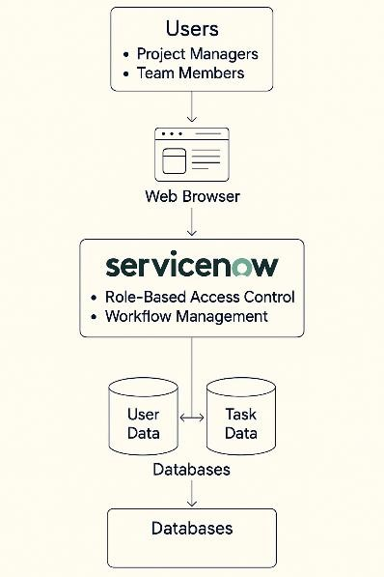

# Table-1: Components & Technologies

**S.No Component Description Technology / Platform**

1. User Interface Web-based interface for Project Manager and Team Members ServiceNow UI Builder, HTML5, CSS, JavaScript
2. Application Logic-1 Workflow orchestration and role assignment logic ServiceNow Flow Designer, Business Rules
3. Application Logic-2 Notification and task lifecycle automation ServiceNow Notification Engine, Script Actions
4. Application Logic-3 Access validation based on roles Access Control Rules, ACLs in ServiceNow
5. Database Stores user data, roles, and task information ServiceNow CMDB and Tables (MySQL under the hood)
6. Cloud Database Cloud-based storage with automated backups ServiceNow Platform-as-a-Service (PaaS)
7. File Storage Attachment handling and storage ServiceNow Attachments Module
8. External API-1 Integration with notification channels (e.g., email, MS Teams) Email API, IntegrationHub connectors
9. External API-2 Optional integration for identity verification OAuth2, Azure AD, or Aadhar API
10. Machine Learning Model Intelligent routing of tasks or anomaly detection (if used) ServiceNow Predictive Intelligence (optional)
11. Infrastructure (Server/Cloud) Cloud deployment and scalability ServiceNow Cloud Infrastructure (Multi-tenant SaaS)

# Table-2: Application Characteristics

**S.No Characteristics Description Technology Used**

1 Open-Source Frameworks Use of client-side scripting frameworks (if extended beyond ServiceNow) AngularJS (in Service Portal), Bootstrap

|  |  |  |
| --- | --- | --- |
| **S.No** | **Characteristics Description** | **Technology Used** |
| 2 | Security Implementations Role-based access control, ACLs, authentication protocols | LDAP, SSO, OAuth2, ACLs, Encryption |
| 3 | Scalable Architecture Modular design with scalable workflows and table structures | ServiceNow Scoped Apps, REST APIs |
| 4 | Availability Highly available via distributed ServiceNow cloud infrastructure | Load-balanced SaaS Architecture |

5 Performance Designed for fast response times with limited API calls and efficient table structures GlideAjax, Scheduled Jobs, Indexing